Harman Birring

OMSBA 5270

8/17/25

**Comparative Analysis of Financial Ratios and Stock Prices Using Python**

**Methodology**

In this project, the analysis combined market data from Yahoo Finance with corporate filings data from SEC EDGAR. The historical daily stock prices for GOOGL were obtained via Yahoo Finance, and annual report filings 10-K were retrieved through the SEC EDGAR system. The key financial ratios were computed to assess the companies' fundamentals, such as the current ratio and the quick ratio. In terms of leverage, I have used the debt-to-equity ratio, and for profitability, I have used ROE and ROA in this report. Each 10-K filing date was treated as an **event**. To capture market reaction, the event date was aligned to the **next trading day** after the 10-K filing since filings often occur after market hours or on non-trading days. Then I calculated **forward stock returns** for multiple windows following each event, like the 5-day return, 20-day return, and 30-day return. I have also applied the t-test to compare pre-event vs post-event performance. This means that it allows me to observe whether stock returns after the 10-K release were significantly different from returns before the event. This helps determine if the 10-K filings tended to trigger abnormal stock moves beyond normal volatility. Additionally, a **correlation analysis** was conducted using the data from multiple 10-K events. This correlation matrix helps identify any relationship between Alphabet's fundamental metrics and the stock's performance after the annual report release.

**Analysis**

In the 5-day window, on average, GOOGL stock has a slight **negative** return in the first week after 10-K filings. The mean 5-day return across the studied events was below 0%, indicating the stock tended to dip in the immediate aftermath of the annual report. A t-test confirms this short-term drop and was statistically significant at the 5% level. This suggests a consistent **sell-off effect** immediately after the annual report is released. The **latest 10-K event** for the most recent year saw an especially sharp decline, roughly a **7% drop within a week** of the filing, far larger than typical. If we look at the 20-day window, the mean 20-day return was slightly negative, approximately 1%, but not statistically distinguishable from zero. This implies that one month after the 10-K, the stock was flat to slightly down. If we look at the 30-day window, the average 30-day post-10K return was **near zero**, marginally negative to flat. Statistically, the 30-day average return was not significantly different. Any immediate adverse reaction tended to **level off within a month or so**, suggesting that Alphabet’s longer-term value prospects were much better. In terms of the latest 10-K, the event had a **notable and significant market impact. Alphabet’s stock price plunged 7% in the days following that filing**, a drop that is **statistically significant** and atypical compared to prior years’ post-10K moves. The figure below shows that the red vertical line marks the next trading day after the 10-K release. A significant price drop occurred immediately after the filing to the right of the red line, reflecting the market’s adverse reaction.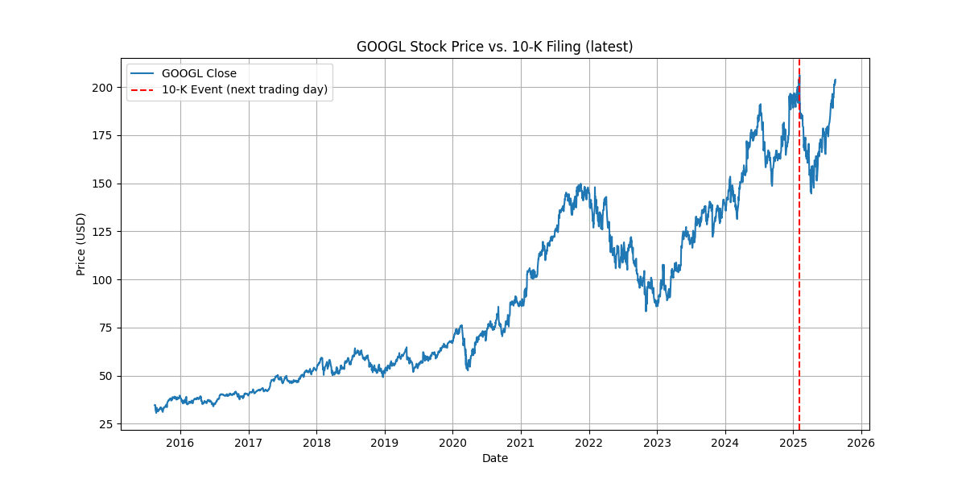

In terms of what drove this sell-off, I believe investors were reacting to specific information in the 10-K and earnings announcements, such as a **slowdown in Google’s cloud business growth and management’s plans for heavy capital expenditures in the future**. Alphabet’s Google Cloud revenue came in below expectations and showed a decelerating growth. At the same time, CEO Sundar Pichai announced plans to **boost capital spending to $75 billion** for AI and infrastructure in the coming year, which was dramatically higher than the $60 billion that analysts anticipated. Alphabet’s shares typically showed strength before the annual report, then a mild decline in the first days after the news. Alphabet had been rallying in the weeks prior; it was up about 9% year-to-date before the report, reflecting optimism around AI and core business trends. Once the actual results and 10-K details hit, revealing **slower cloud growth and huge spending plans, investors swiftly sold the news.** It’s important to note that this behavior doesn’t mean Alphabet’s long-term prospects are poor. Indeed, the stock’s recovery within a month suggests that many investors **bought the dip, showing confidence in the company’s fundamentals.**

**Conclusion**

In conclusion, this event study of Alphabet’s 10-K filings underscores a few key points for investors. First, market reactions around annual earnings disclosures can follow a **predictable emotional pattern, buy the rumor, sell the news**, so being aware of that pattern helps in timing and risk management. Second, the content of the 10-K, especially details on growth segments and spending plans, can explain why a stock moves the way it does. An investor will read beyond the headline earnings numbers and focus on segments like cloud and on indicators to judge market sentiment. Finally, employing a structured event study approach for major filings can be a valuable tool to bridge the gap between **market expectations and company reality**. If I were an investor, I would buy the stock as a long-term investor rather than a short-term trader because the fundamentals are strong, the adverse reaction was short-lived, and the event study shows no evidence of persistent damage. Long-run correlations with ratios ROE and ROA suggest profitability is still the main driver.